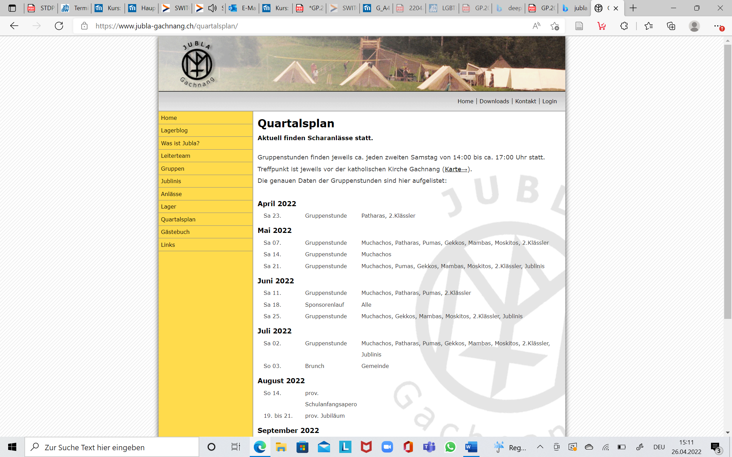

Sponsorenlauf 14.Juni 2025

Jublaname: __________________________ Gruppe: ___________________________________

|  |  |  |  |  |  |
| --- | --- | --- | --- | --- | --- |
| Name Sponsor | Strasse | Ort | Betrag pro Runde (1 Runde ist ca. 1km) in Franken | Unterschrift | Schlussbetrag in CHF mit Visum Leiter |
|  |  |  |  |  |  |
|  |  |  |  |  |  |
|  |  |  |  |  |  |
|  |  |  |  |  |  |
|  |  |  |  |  |  |
|  |  |  |  |  |  |
|  |  |  |  |  |  |
|  |  |  |  |  |  |
|  |  |  |  |  |  |
|  |  |  |  |  |  |
|  |  |  |  |  |  |
|  |  |  |  |  |  |
|  |  |  |  |  |  |